Activate additional CPE

Version Control:

Use Case Name: |  | Activate additional CPE
Use Case Owner: |  | Sumit Borade
Current Version |  | 0.5
Use Case Version History
Modified Date | Version |  | Modified By | Change Description
June 28, 2009 | 0.1 |  | Tom Schnarr | Initial Version
August 26,2009 | 0.2 |  | Sumit Borade | Removed steps not relevant to SMP
September 30,2009 | 0.3 |  | Sumit Borade | Updated to add additional Steps for Static IP
Oct 2,2009 | 0.4 |  | Sumit Borade | Removed the step for Static IP Reservation by GI Addr
Oct 28,2009 | 0.5 |  | Sumit Borade | Updated after Dicussion with YouSee

Brief Description:
This use case describes the process by which a YouSee subscriber orders an additional CPE service with a dynamic IP Address. The use case is written from the perspective of the SMP provisioning solution.

Related Documents
- YouSee SMP SOW2Architecture Requirements Document
- YouSee SMP SOW2 Business Requirements Document
- Cisco BACC TC Specification

Related Use Cases

Pre-Conditions
- Subscriber is an active broadband subscriber

Post-Conditions
- Subscriber is free to use Broadband over Cable service from an additional CPE device

Use Case

Primary Flow Diagram
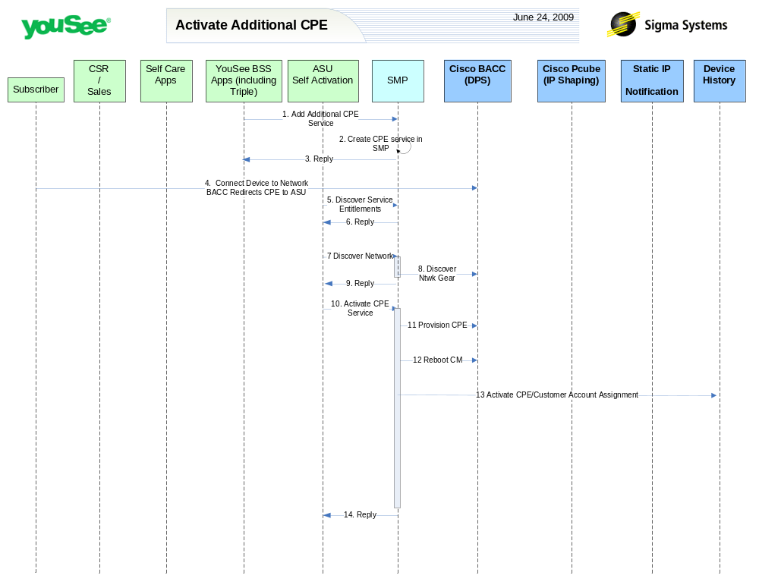

Primary Flow Detail
# | Actor: Key Action | Description | Alternate Flows/Details
 | YouSee BSS: Order is communicated to SMP for Additional CPE | YouSee BSS (Triple) will communicate the order to SMP through SMP’s OSS/J Order Management API. Triple will provide logical services and service attributes. SMP will be required to translate these service/service attributes to engineering level resources and resource attributes.
 | SMP: Additional CPE Service | SMP will create additional CPE service under the Broadband Cable Service plan .. SMP will not provision on Network element(CPE Mac address) since Additional CPE information like CPE MAC address is not available.
 | SMP: SMP will reply back the status of Order to Triple | SMP will reply back the status of the Order to Triple.
 | Subscriber: connects new PC to CM and launches a browser. Network (BACC) redirects browser to ASU | The Subscriber connects new PC to the active CM. The new PC will be assigned an IP from BACC RDU which redirects user to ASU registration portal.
 | ASU: request service entitlements from SMP | <As in Activate Broadband Use Case>
 | SMP: SMP sends reply to ASU for Service Entitlement Information | <As in Activate Broadband Use Case>
 | ASU: requests SMP to discover network gear | <As in Activate Broadband Use Case>
 | SMP: queries BACC and internal inventory to find network gear serving subscriber | <As in Activate Broadband Use Case>
 | SMP: Replies back to ASU the information received from CISCO BACC | <As in Activate Broadband Use Case>
 | ASU: requests SMP to activate service | ASU will request SMP to activate service by generating an order in SMP assigning the CPE MAC to the appropriate service.
 | SMP: defines CPE in BACC | For the CPE MAC address supplied from ASU, SMP will define that MAC address as a ‘Computer’ object in BACC.
 | SMP: requests BACC to reboot the CM Device | <As in Activate Broadband Use Case>
 | SMP: add request to IP History System | <As in Activate Broadband Use Case>
 | SMP: Replies back to ASU the status of Activation | SMP will reply the status of Provisioning Order to ASU.

